

Pattern Order Form

Each pattern is sold as an electronic copy in pdf format, which can be opened with Adobe Acrobat or other pdf reader. Patterns will be e-mailed, in a PDF format, to you when the check arrives. Each pattern includes:

* Supply list
* Abbreviations
* Color options (Primarily based on Sugar N Cream Yarns)
* Written instruction
* 2 Color Charts - One for each side (while knitting even & odd rows)
* Un-colored chart(s) for you to test out your own yarn color combinations with color pencils or to ‘print screen’ and paste into Microsoft paint to pour color into the squares.

Please make Checks Payable to Sue Gregori and mail to:

**Sue Gregori**

6106 Laird Avenue

Oakland, CA 94605

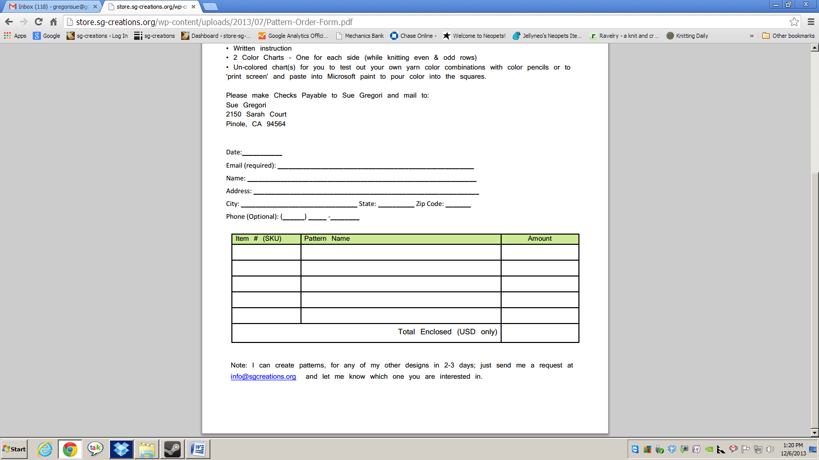

Note: I can create patterns, for any of my other designs in 2-3 days; just send me a request at [info@sg-creations.org](mailto:info@sg-creations.org) and let me know which one you are interested in.